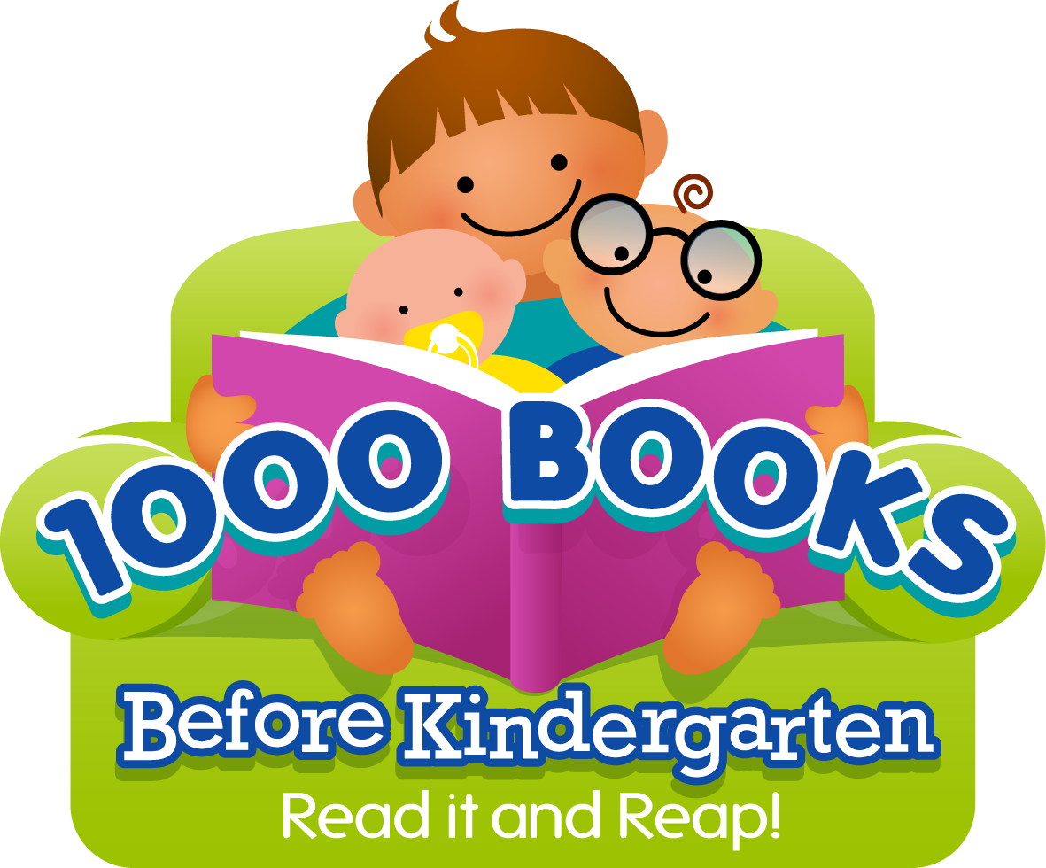
Welcome to the Sergeant Bluff Library’s 1,000 BOOKS BEFORE KINDERGARTEN PROGRAM!

Did you know that reading to your child is one of the most powerful ways to boost his or her brain power? The simple and enjoyable act of sharing books helps your child learn pre-reading skills such as understanding the sounds letters make, developing a bigger vocabulary, and building background knowledge—all important skills that help prepare your child for learning to read and entering kindergarten.

Sergeant Bluff Library’s 1,000 Books Before Kindergarten program is a fun, exciting, and free way to start your child on the path to success! Any child ages birth to five years can participate. Just follow these steps:
- Register: Sign up at Sergeant Bluff Public Library or online at www.sergeantbluff.lib.ia.us. Pick up program materials at the library or print them from our website. You can even download a free app from your app store. Look for “1000 Books Before Kindergarten”.
- Track Your Reading: Fill in a circle or write down each book you read with your child on your reading record, or record in the app.
- Every Book Counts: Even if your child wants to hear the same book again and again, you can count it each time. You can also count the books your child hears in storytime, in daycare or preschool, or with a friend or family member, as long as your child listens to the entire book.
- 100-Book Milestones: Each time you read 100 books, bring your reading record to the library to receive a special reward. Take home a new reading record for your next 100 books.
- 1,000 Books: You did it! Come celebrate at the library, see your child’s name placed on the 1,000 Book Wall of Fame, and receive a free book.
- Keep on Reading: Don’t stop at 1,000! Keep on reading together; there’s more learning ahead!

Singing songs, saying rhymes, telling stories, and playing with your child are all great ways to build their literacy skills.

One thousand books may seem like a lot, but if you read just one book a night, you’ll meet your goal in less than 3 years. If you read three books a night, you could reach your goal in just one year! Ask our friendly staff for suggestions—we’re here to help you on your journey to 1,000 Books Before Kindergarten!

Happy Reading!

