Sergeant Bluff Public Library Board Meeting
Wednesday June 17, 2026, 5:30 pm
SBPL, 503 4th St. Sergeant Bluff, IA 51054

Board of Trustees:
Michael Aguirre (President) [ ] – term exp. June 2029
Shannon Maier (Vice Pres.) [ ] – term exp. June 2029
Jane Schaar (Secretary) [ ] – term exp. June 2031
Alisha Elder [ ] – term exp. June 2031
Deb Collins [ ] – term exp. June 2027
Lisa Lauters [ ] – term exp. June 2027
Alicia Schaben [ ] – term exp. June 2031
Mary Torgerson (Library Director) [ ]

AGENDA:

- Call to Order
- Minutes Approval from 5/20/2026
  - Minutes are available on our website
- Agenda Approval
- Bill Approval
- Treasurer’s Report
- Public Comment

- Librarian’s Report for May 2026

  - May door count-1466
  - Last month April door count-865
  - Last year –May 2025- 1711
  - 2 years ago -May 2024-707

  - Patrons added May -12 ( total card holders-2413)
  - Adult Books: May 2026-148 May 2025-141
  - Children/Teen Books: May 2026 - 371 May 2025-258
  - DVDs: May 2026 –14 May 2025-22
  - Miscellaneous May 2026 -7 May 2025-2

  - Bridges
  - audio books: May 2026 – 327 May 2025-288
  - eBooks: May 2026- 179 May 2025-182
    - magazines May 2026 – 6 May 2025-6
  - WhoFi Internet
    - Total monthly usage- May– 224 visits / 372 hours, 46 minutes
    - Last Month –- April – 274 visits / 434 hours, 36 minutes
    - Unique visitors – May - 82
    - Last Month – April - 91
    - Website Counter- 4062

  - Programs
      - Children-22(490)
      - General Interest - 4(78)
4. Total- -30 (568)

UNFINISHED BUSINESS
1. New Board Member welcome
2. Policy Review – Emergency update
3. STEM kits
4.June Continuing Education- StarNet Website- Science Across America
www.starnetlibraries.org

NEW BUSINESS
5. Policy Review – Computer & Internet
6. Director Evaluation
7. July 3rd -close at noon or 1.
7. July Continuing Education- Board Room essentials- View the whole series on YouTube.

Other Business
NEXT MEETING(s): Regular Board Meeting- Wed July 15, 2026 @ 5:30 pm

Library Board of Trustees Calendar
National Library weeks/days, and monthly agenda items

January
Policy Review – Behavior Policy
Programming Review for Q2 of Current Year
Librarian Recertification Applications - Due Jan 31.
SBPL Annual Budget Presentation to City - Next Fiscal Year (FY) to City

February
Policy Review – Collection Policy
Library Accreditation Application Deadline - Feb 28
Programming Updates/Changes for Q2 of Current Year

April
Policy Review – Circulation Policy
BRIDGES Letters of Agreement - Due in April

April
Policy Review – Confidentiality Policy
Review SBPL Bylaws & Update if needed
Review of Trustee Terms Expiring End of June (begin recruitment for new trustees)
National Days/weeks
• D.E.A.R. Day - Drop Everything and Read Day - April 12
• National Library Week
• National Library Workers Day
• National Library Outreach Day
• Take Action for Libraries Day
• National Money Smart Week
Enrich Iowa Letters of Agreement Due April 29 (30th at 12:00AM)
Programming Review for Q3 of Current Year
Final SBPL Budget - Next Fiscal Year (starting in July) Approved by City of Sergeant Bluff.

May
Policy Review – Emergency Policy
National Days/Weeks
• Children's Book Week
• National Choose Privacy Week
Programming Updates/Changes for Q3 of Current Year
Library Director to complete staff performance review(s) & merit recommendations
Library Board to complete director performance review & merit recommendations
June
Policy Review – Computer & Internet
SBPL Staff Performance Evaluations (within approved budget; effective in July)
• Library Director to present Staff Performance Review & Merit Recommendations
• Library Director Performance Review & Merit Recommendations
Summer Reading program Starts
Iowa State Direct State Aid Funds Expended by June 30
Enrich Iowa Reports for FY'21 - Due July 31

July
Short Meeting to sign bills
New Fiscal Year Budget Begins (FY = July 1 - June 30)

August
Policy Review – Meeting Room Policy
Election of Officers - President, Vice President, Secretary, and Committees

September
Policy Review – Gifts & Donations Policy
National Days/Weeks
• Library Card Sign-up Month
• Banned Books Week
• Banned Website Awareness Day

October
Policy Review – Financial Card Policy/ StoryWalk Fundraising Policy
Library Director Begins Annual Budget Development for next Fiscal Year (FY) (@Aug-Oct)
Iowa State Library Annual Survey - Due Oct 31

November
Policy Review – Reconsideration Policy
Library Director Presents Annual Budget to Board for next FY (present to City in January)
National Days/Weeks
• National Children's Book Week
Programming Review/Approval for Q1 of Next Year (Jan-Mar)
Continuing Education (CE) Credit Hours submission for Certification - Due Dec 31

December
Short meeting to sign bills

Bills Paid May 2026

Invoice #--------------------------Vendor----------------------Code----------------------------------Total

5582780914--------------------------Google Workplace------------6373(Tele)----------------$44.94

596------------------------------------MidStep_______________6409(Janitor)__________$260.00

111-7847478-4132233--------------Amazon----6599—(Misc. Expenditures-)------$679.99

111-8769852-0015406----------Amazon---------6511 (books)-----------------------$44.39

111-7356830-1834660-------Amazon-----------6511(books)-----------------------$334.90

111-5259770-4671412---------Amazon---------6511(books)----------------------$7.05

114-6631846-4743440---------Amazon---------6599(Misc.Exp)------------------$33.16

114-9878050-0181023---------Amazon----------6599 (Misc.Exp) ----------------$133.68

02-----------------------Easton Boettcher---------6215(Summer)-------------------$100.00

Advocate----6512-------------------------------------------------------------------------$30.00

0730032-01--------------------------Longlines----------6373 (Tele)------------------------$43.39

June Total----------$1711.50

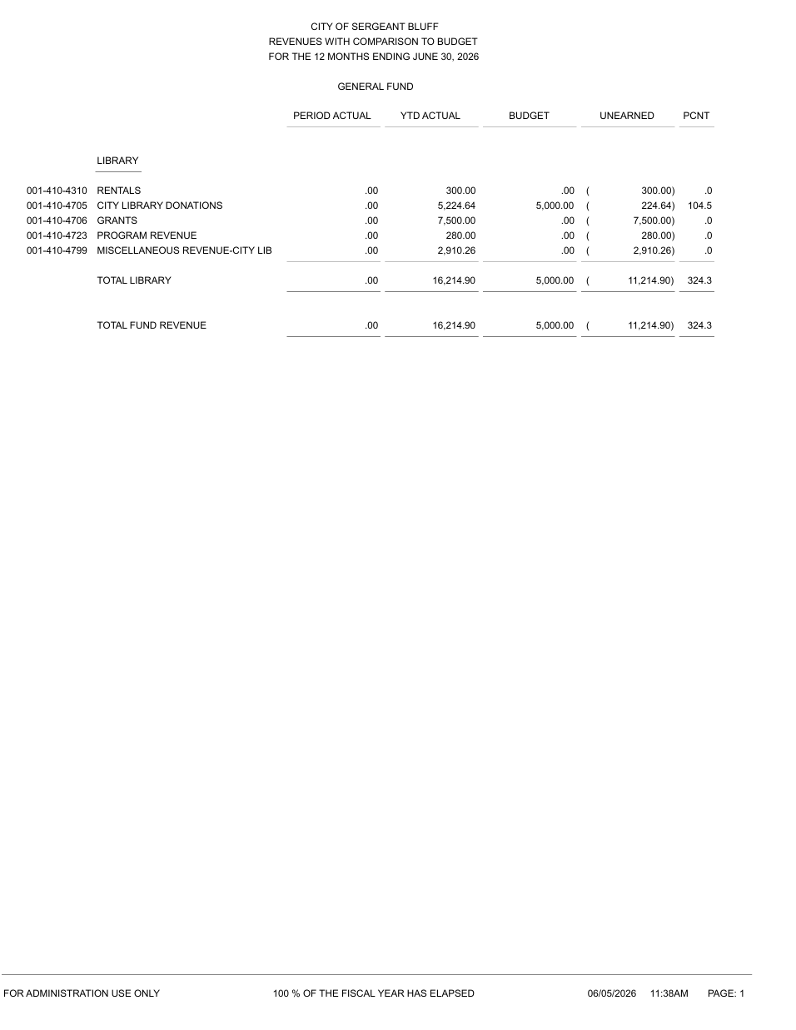

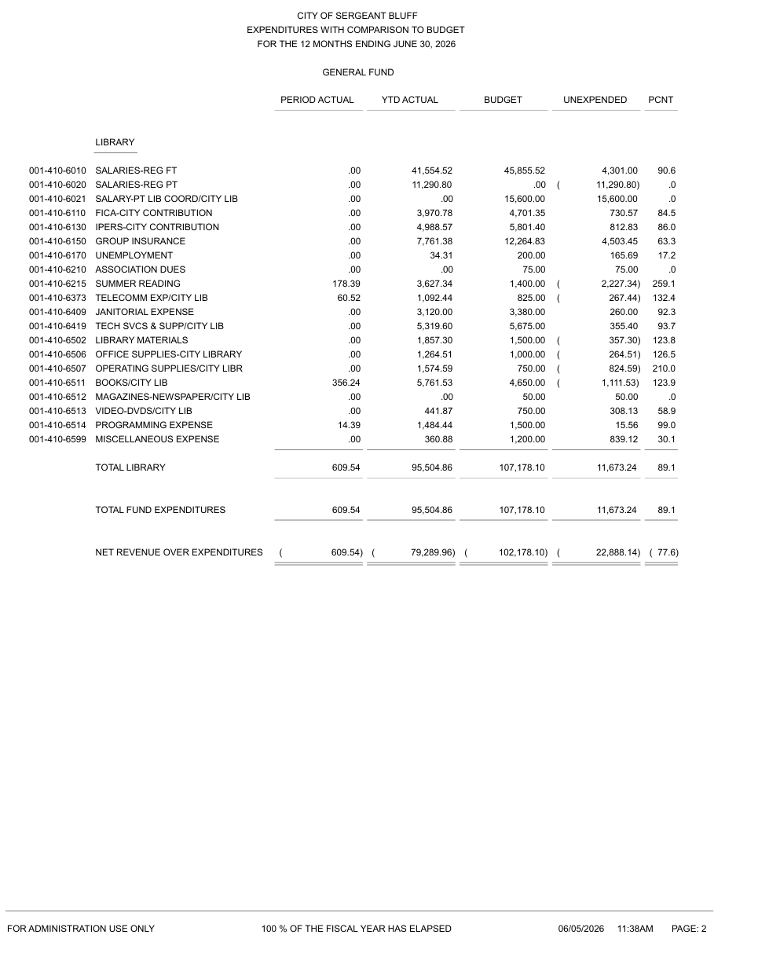

Sergeant Bluff Public Library
Emergency Policy
This policy outlines protocol for emergencies of all kinds.

EMERGENCY PHONE NUMBERS
Fire Department 911 712-943-5000 (non-emergency)
Police 911 712-943-9603 (non-emergency)
Library Director Mary Torgerson 712-281-4210
City Hall Office 712-943-4244
Electrician/Plumbing/Mechanical 712-943-4244
EMERGENCY EQUIPMENT
First Aid Kit Located at the circulation desk
Flashlights Located at circulation desk and in space leading to the emergency shelter Emergency lights come on when power is out; can be used as flashlights
Fire Extinguishers Located at front door and by bathrooms
Weather Radios Located at circulation desk and in Library Director’s office

FIRE
Upon discovery of a fire, library staff will ask patrons to exit the building.
If fire is in its early stages, such as a trash can or a small pile of paper, library staff will use the nearest fire extinguisher. If fire cannot be contained with a fire extinguisher, staff in charge will:
- Evacuate the building immediately, doublechecking to ensure all patrons have exited.
- Call 911!
- Gather everyone in front of the Long Lines building across the street or another safe place based on the fire location.
If possible, the librarian in charge should try to close the door to the burning area to confine the fire and minimize the spread of smoke. No one may return to the building for any reason until approval is given by the Sergeant Bluff Fire Department.

MEDICAL EMERGENCY
In case of a medical emergency, call 911.

SEVERE WEATHER
In case of severe weather, library staff will monitor online and with weather radios.
Tornado
A tornado WATCH is declared when conditions are favorable for tornadoes but no tornadoes have been sighted. Librarian will make patrons aware of the WATCH at this time
A tornado WARNING is declared when a tornado has been sighted in the area. The City of Sergeant Bluff’s tornado siren will be activated. (This sounds like the fire siren but will sound for three full minutes without stopping.)
When the tornado siren sounds:
- Librarian in charge will notify patrons that a tornado warning is in effect.
- Library staff will direct patrons to the designated shelter area. Closet used for storytime supplies and back hallway nearest City Hall door.
- Library staff will get the weather radio and flashlight and join patrons in the shelter area.
- Everyone will remain in the designated shelter and wait for all clear.

Snowstorm
Sergeant Bluff Public Library hours mirror the hours of the City of Sergeant Bluff offices.
If a snowstorm begins during the day, library staff will stay tuned to news reports, monitor information online, and use their best judgment about opening or closing the library.
Weather-related updates will be posted to local news outlets and social platforms for Sergeant Bluff Public Library and the City of Sergeant Bluff.

REVISED: 6/2/0206
APPROVED: 6/17/2026

Computer and Internet Use Policy
This policy provides guidelines for computer and internet use.
In order to support the community’s informational, educational, cultural, and recreational needs, Sergeant Bluff Public Library provides free internet access. Please note that our wireless network is not secure; the library is not responsible for any issues resulting from wireless access.

USAGE GUIDELINES
General usage guidelines are as follows:
- Sergeant Bluff Public Library staff members are not responsible for monitoring or controlling information accessed.
- Use of the Internet is open to the general public.
- Computers may not be reserved and are available on a first-come, first-served basis.
- Children under age 10 must be supervised by a parent or guardian. Parents or guardians are responsible for all information accessed by children under age 10.
- Sergeant Bluff Public Library cannot control content, quality, or accuracy of information accessed online. Patrons should carefully evaluate information obtained online.
- Individual sessions are limited to 60 minutes unless circumstances require longer sessions. Additional time may be approved by library staff.
- Patrons must respect the privacy of others who are using the computers.
- No more than two people may sit at one computer.
- Food or drink is not allowed near the computers.
- Patrons should not shut down computers when they are finished; library staff will power down computers at the end of the day.
- Patrons may not make changes to any computer settings.
- Library staff will provide assistance to the extent possible.
Sergeant Bluff Public Library abides by all guidelines within the federal Children’s Internet Protection Act. A copy is available at the front desk of Sergeant Bluff Public Library.

PROHIBITED PRACTICES
Sergeant Bluff Public Library reserves the right to restrict or terminate computer privileges of anyone who does not practice responsible online access. This includes—but is not limited to—the following:
- Downloading or sending pornographic or sexually graphic material
- Violating copyright laws
- Participating in online harassment
- Attempting to make unauthorized entry into other computers
- Distributing unsolicited information
- Making any changes to the hard drives of library computers
- Damaging or destroying equipment, software, or data belonging to the library

TECH SERVICES
Sergeant Bluff Public Library is currently a cash-only organization. Credit and debit card payments cannot be accepted. An ATM is available next door at City Hall.
Faxing: 25 cents per page
Copying: 25 cents per page for black & white
50 cents for color
Printing: 25 cents per page for black & white
50 cents for color
Please note: If students need copies for school, the price is 10 cents per page for black & white copies and 25 cents per page for color copies.

Notary Service: $5
We have a notary public for patrons who might need documents witnessed and signed. Please note that a notary is neither an attorney licensed to practice law in Iowa, nor is a notary allowed to draft legal records or give advice on legal matters.

REVISED: 6/19/24
APPROVED: 6/17/26

